**KITCHEN EXHAUST FANS:**

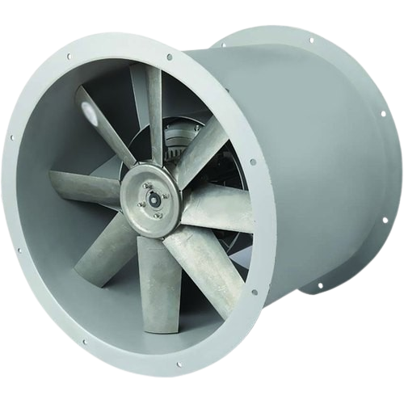

**Price: 3,150.00**

The Kitchen Exhaust Fan is a powerful and efficient ventilation solution, specifically designed to remove cooking fumes, grease, and moisture from kitchens. With its high-airflow capacity and durable construction, this fan effectively eliminates cooking odors and pollutants, improving indoor air quality. Its easy installation, low maintenance requirements, and sleek design make it a practical and stylish addition to any kitchen, ensuring a healthier and more comfortable cooking environment.

**Key features of kitchen exhaust fans include:**

* **High Airflow:** Efficiently removes smoke, heat, and odors from the kitchen.
* **Durable Construction:** Made with corrosion-resistant materials for long-lasting use.
* **Powerful Motor:** Ensures effective ventilation and air circulation.
* **Energy Efficient:** Low power consumption for cost-effective operation.
* **Quiet Operation:** Designed to minimize noise during use.
* **Easy Installation:** Simple to install in various kitchen setups.
* **Hygienic:** Helps maintain a clean and fresh environment by eliminating cooking fumes.